|  |
| --- |
| Smith-Plante Family |
| ***Smith-Plante Family Cookbook*** |
| Fun and delicious home-style recipes for any cravings you might have. |

**Chocolate Chip Cookies**

Combine in two separate bowls:

First Bowl:

* 2 ½ cups of four
* 1 tsp. salt
* 1 tsp. baking powder/soda (depending on cookie preference)

Second Bowl:

* 1 cup brown sugar
* 1 cup (2 sticks) butter
* ½ cup sugar
* 1 tsp. vanilla
* 2 eggs

Add flour mixture to the second bowl and fully blend together. Now add in chips (2 cups). Bake at 375° for about 10 -12 minutes or till cooked to personal preference.

**Banana Bread**

Combine Ingredients:

* 1 ½ cup flour
* 1 cup sugar
* ½ cup Crisco
* 2 tsp. baking powder
* ½ tsp. baking soda
* Pinch of salt
* 6 mashed bananas
* 2 eggs

Optional:

* ½ cup of desired nut blend

Pour mixture into a greased loaf pan and bake at 300° for 75 minutes.

**Peanut Butter Fudge**

Cook in a large pot with handle

* 2 cups sugar
* ½ cup milk

Cook sugar and milk on medium high for 20 – 30 minutes or till stringy.

Carefully mix in combined ingredients:

* 1 cup peanut butter
* 1 tbsp. butter
* 1 tsp. vanilla

Pour mixture into a greased pan then let cool.

**Easy Peanut Butter Fudge**

Melt butter in microwave for 30 seconds.

* 2 sticks of butter (8oz)
* 1 cup of peanut butter

Mix peanut butter into melted butter and heat for another two and half minutes.

* 1 lb. of powder sugar
* 1 tsp. of vanilla

Blend together all ingredients then pour and shape into greased pan.

**7 Layer Salad**

* Layer of lettuce
* Red onion chopped
* Celery chop fine
* Bacon 1 lb. Cooked and crumble
* Frozen Peas. 1 small bag
* Shedder cheddar cheese
* 2 cups Hellman’s mayo spread over tops of each layer
* Cover and chill overnight

**Chili**

Cook and season:

* 1 lb. ground beef
* 1 lb. ground sausage

Drain grease then add in crock pot with:

* 16oz can of kidney beans
* 30oz can of crushed tomatoes
* 1-2 cans of green chilies
* 2 cans of tomato sauce
* 1 green, red, and yellow bell peppers cut into strips
* 1 large red onion
* 5 Tbsp. chili powder
* 2 diced garlic cloves
* 4 Tbsp. crushed basil

Cook in crock pot till veggies are tender.

**Cranberry muffins**

1 cup fresh cranberries

¼ cup sugar

1 ½ cup all purpose flour

¼ cup sugar

2 Tsp. baking soda

1 Tsp. salt

½Tsp. cinnamon

1 egg

¼ Tsp. Orange zest

¾ cup orange juice

1/3 cup melted butter or margarine

¼ cup walnuts

1. Cut cranberries in half and mix with ¼ cup sugar. Let stand
2. In a bowl, mix flour, sugar, baking powder, salt and cinnamon and make a hole in the center
3. Mix the egg, orange juice, orange zest and butter and mix with dry ingredients
4. Add cranberries and walnuts
5. Put muffin mix in molds and cook at 375F for 15 to 20 minutes or until the muffins are a nice golden color
6. Enjoy ☺

**Lamb stew with dried plums, from the Hunger Games**

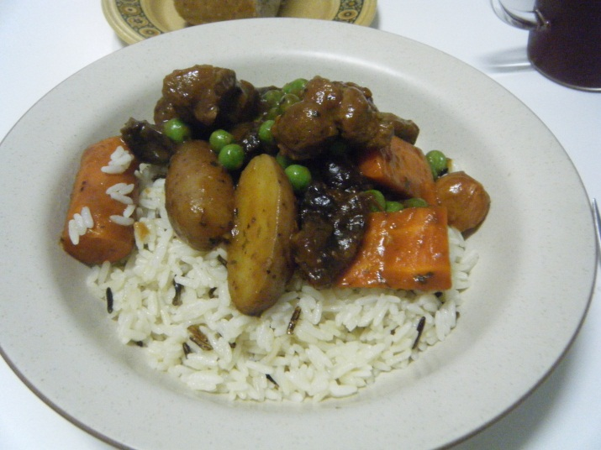Ingredients

* 3 lbs lamb meat, cubed
* 2-3 tbsp cooking oil
* 1 tbsp sugar
* 3 tbsp flour
* 2 cans beef broth
* 1 cup tomato pulp or 3 tbsp tomato paste
* 1 sprig rosemary, leaves snipped
* salt to taste
* pepper to taste
* 3 large carrots, peeled and chopped
* 2 medium potatoes, peeled and chopped
* 16-18 pearl onions, peeled and halved
* 1 cup frozen or fresh peas
* 1 handful dried plums cut in half

1. Heat oven to 475 degrees.
2. Heat oil in a skillet and brown lamb meat. Transfer to dutch oven as pieces cook.
3. Sprinkle sugar on browned meat. Cook meat for several minutes on medium high heat to caramelize sugar.
4. Toss meat with flour until well coated. Place pot in oven uncovered for 5 minutes. Toss meat around and cook for another 5 minutes. Reduce oven heat to 350 degrees.
5. Add 1 1/2 cans of beef broth, tomato pulp, and rosemary. Cover and cook on bottom third of the oven for 1 hour.
6. Taste and season with salt and pepper as needed. Add carrots, onions, and potatoes and more broth if needed.
7. Cover and return pot to oven for another hour. After 30 minutes, add dried plums. Once done, taste and season as needed.
8. On the stovetop, boil peas for 1-2 minutes. Drain and add to stew just before serving.
9. Serve on wild rice with nut bread.

**Spanish hot chocolate**

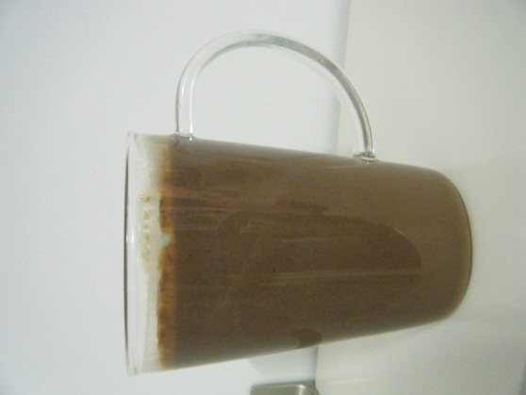1 tbsp cornstarch  
2 cups milk (any kind)  
1/2 cup semisweet chocolate (chocolate chips)  
1/4 cup sugar

Whisk together the cornstarch and milk. Add mixture, along with chocolate and sugar, to a small saucepan. Bring just to boil, whisking occasionally, and cook until sauce has thickened. Remove from heat.

**Molasses cookies**

* 1 cup sugar
* ¾ cups Crisco
* ¼ cup molasses
* 1 egg
* 2 cups all purpose flour
* 2 ½ tsp baking powder
* 1 tsp cinnamon
* 1 tsp powdered ginger
* 1 tsp ground cloves
* sugar

Combine sugar, Crisco, molasses and egg in 1 bowl using an electric mixer

Add flour, baking powder and spices until smooth

Make small balls (1 inch wide) with cookie dough and roll in sugar.

Cook for 8 to 12 minutes in oven at 350°

Enjoy ☺

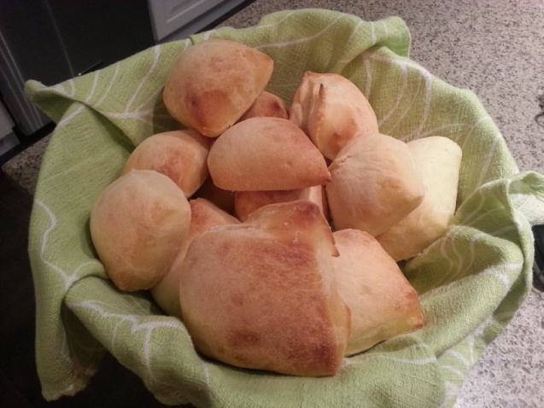**Texas Road House Sweet Yeast Rolls**  
  
1/2 sol. oz. cake of yeast or 1 pkg. active dry yeast  
1/2 c. warm water  
2 c. milk  
3 tablespoons of melted butter  
1/2 c. sugar  
2 qt. all purpose flour  
2 whole eggs  
2 tsp. salt  
  
Soften yeast in warm water with a teaspoon of sugar. Scald milk; cool to lukewarm. Add yeast, sugar and enough flour to make a medium batter. Beat thoroughly. Let stand until light and foamy. Add melted butter (which has been cooled), eggs and salt. Beat well. Add enough flour to form soft dough. Sprinkle small amount of flour on counter and let dough rest. Meanwhile, clean and dry bowl; grease clean surface of bow. Knead dough until smooth and satiny. Put in greased bowl; turn over to grease top. Cover; let rise in warm place until double in bulk. Punch down. Turn out on floured board. Divide into portions for shaping; let rest 10 minutes. Shape dough into desired forms. Place on greased baking sheets. Let rise until doubled. Bake at 375 degrees for 10 minutes; reduce temperature to 350 degrees for 10 to 15 minutes more. Cool on rack.   
  
Yield: 5 to 6 dozen

Ron’s Vanilla Cake

Cake:

* 1 cup powder sugar
* ½ cup butter
* 2 eggs
* 2 teaspoons vanilla extract
* 1 ½ cups all-purpose flour
* 1 ¾ teaspoons baking powder
* ½ cup milk

1. Preheat oven to 350 degree
2. Grease a 9*9 inch pan
3. In a medium bowl cream together the sugar and butter
4. Beat in the eggs one at a time, then stir in the vanilla
5. Combine flour and baking powder in separate bowl
6. Combine both mixtures
7. Stir in the milk until smooth
8. Pour in pan and bake for 30 minutes

Frosting:

* 2 ½ sticks of butter
* 5 cups powder sugar
* 1 tablespoon vanilla
* 1 -2 tablespoons milk

1. In large bowl beat butter at medium speed
2. Add in powder sugar, 1 cup at a time
3. Add vanilla and milk
4. After cake has cooled apply frosting
5. Enjoy

Boeuf Bourgignon

**Ingredients:**

2 tablespoons vegetable oil  
2 pounds boneless beef chuck, cut into 1-inch pieces  
2 cups carrots, cut into thin pieces about 4-inches in length  
2 stalks celery, sliced  
1 small yellow onion, peeled and diced  
14 1/2 ounces diced tomatoes, undrained  
1 cup white button mushrooms, chopped  
1 cup dry red wine  
1 teaspoon salt  
1 tablespoon fresh thyme leaves, chopped  
1 teaspoon fresh basil, minced  
1 teaspoon dry mustard  
1/4 teaspoon freshly ground pepper  
1/4 cup water  
2 tablespoons flour

**Directions:**

In a large skillet placed on stovetop set to medium-high heat, add oil.  
Once the oil is hot, sear beef, turning each piece as it browns. Repeat with the remaining beef until it has all been browned. Transfer beef into the stoneware and place in slow cooker heating base.  
Add the carrots, celery, onion, tomatoes, mushrooms, wine, salt, thyme, basil, mustard and pepper.  
Cover and put slow cooker on ‘’low’’. Forget about it for about 8-10 hours. Go shopping, do some homework, watch Sherlock, take a shower, make some tea, take a nap, enjoy the awesome smell, basically don’t touch it for about 8-10 hours.

Thirty minutes before serving, combine the water and flour in a small bowl until smooth. Turn the heat to High. Gradually add the flour and water to the soup and stir until the sauce thickens, about 3 to 5 minutes. Heat through and serve.

Crêpes

1 cup flour

Salt

½ teaspoon baking powder

1 cup milk

4 eggs

1. Mix dry ingredients
2. Mix in milk
3. Add eggs
4. Tell Rick not to laugh at my crêpes

**Chicken & Dumplings**

* 1 large onion, diced
* 1 can (10.5 oz.) cream of celery soup
* 1 can (10.5 oz.) cream of chicken soup
* 1 tablespoon fresh parsley
* 1 teaspoon poultry seasoning
* black pepper to taste
* 4 skinless boneless chicken breasts
* 2 cups low sodium chicken broth
* 2 cups frozen vegetables or peas and carrots, defrosted
* 1 can (8 pieces) refrigerated biscuits (Buttermilk, Country or Homestyle)

1. Cook on high heat for 5 hours. Only add the biscuits for the final hour.